SeatBook
Seat Management (Workforce Management)
Application Documentation
Overview · Features · Administration · Architecture · Data · Security · Integrations · Quality · Operations

Version | 1.0
Date | 26 October 2026
Audience | Business stakeholders, customers, partners and new team members
Covers | SeatBook web application and platform as released on the dev branch

About this document
This document describes SeatBook, a desk and visitor booking platform for hybrid offices: what it does, who uses it, how everyday tasks work, how administrators configure it, and how the platform is built, secured and operated.
Terms are explained in the glossary at the end of the document.

Where to start
If you are… | Read
Business stakeholder | 1 Introduction to SeatBook, 3 Capability Overview, 16 System Architecture
Employee or coordinator | 5 Booking a Desk, 6 Booking for Others and Visitors, 8 Chatbot Assistant
Reception | 7 Front Office: Visitor Arrivals
Workplace administrator | Part III (chapters 10–15)
IT, security or architecture reviewer | Part IV (chapters 16–23)

Contents
Part I — Introduction 4
Chapter 1. Introduction to SeatBook 5
Chapter 2. Users and Roles 7
Chapter 3. Capability Overview 9
Part II — Using SeatBook 11
Chapter 4. Signing In 12
Chapter 5. Booking a Desk 14
Chapter 6. Booking for Others and Visitors 17
Chapter 7. Front Office: Visitor Arrivals 19
Chapter 8. Chatbot Assistant 20
Chapter 9. Teammates and Profile 21
Part III — Administration 22
Chapter 10. Offices, Buildings, Floors and Amenities 23
Chapter 11. Floor Plans and Seats 25
Chapter 12. Blocking Seats 26
Chapter 13. Users and Roles Administration 28
Chapter 14. Dashboard, Booking Oversight and Audit Log 30
Chapter 15. Configuration: Business Rules 31
Part IV — Technology 32
Chapter 16. System Architecture 33
Chapter 17. Technical Design Highlights 37
Chapter 18. Data Model 39
Chapter 19. Security and Data Protection 43
Chapter 20. Integrations and Notifications 46
Chapter 21. API Overview 48
Chapter 22. Quality Assurance 50
Chapter 23. Deployment and Operations 52
Appendix 54
Chapter 24. Glossary 55

Part I — Introduction
What SeatBook is, who uses it, and what it can do.
Chapter 1 Introduction to SeatBook
Chapter 2 Users and Roles
Chapter 3 Capability Overview

Chapter 1. Introduction to SeatBook

1.1 What SeatBook is
SeatBook is a web application that helps organisations run hybrid offices. Employees reserve a desk for the days they come in, choosing it on an interactive floor plan. Coordinators book for colleagues and visitors. Reception sees who is expected each day and records arrivals and departures. Workplace administrators shape the office layout, set the booking rules, and follow how the space is used.
SeatBook serves several customer organisations from one platform. Each organisation (a tenant) works in its own fully separated space, signs in with its own Microsoft identity, and sets its own rules.

1.2 Why it matters
Business need | How SeatBook meets it
People need a guaranteed desk on the days they come in | A desk is reserved for a specific day and cannot be taken by anyone else
Facilities teams need to plan space | Interactive floor plans, amenities per seat, blocking of seats, and occupancy views
Teams want to meet in the office | Employees see which teammates are in and where they sit
Visitors should be expected and welcomed | Visits are registered in advance, with a host and optionally a desk; reception checks them in
Each organisation has its own policies | Booking windows and other rules are configured per organisation, without code changes
Access must follow the organisation | Sign-in with the corporate Microsoft account; role changes take effect immediately
Actions must be traceable | Every significant action is recorded in an audit log

1.3 Who uses it
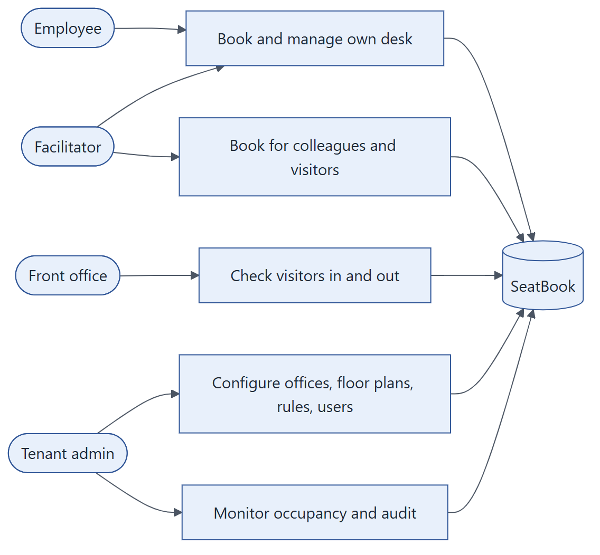
Figure: Who uses SeatBook and for what.

1.4 Highlights
- Desk booking on a real floor plan. Free, booked and blocked seats are shown in colour on the office's own drawing.
- No double bookings. Two independent safeguards guarantee one person per desk per day, even when people click at the same moment.
- Book for others. Facilitators and administrators book for employees and register visitors in one step.
- Reception view. A focused screen for today's visitors with one-click check-in and check-out.
- Conversational assistant. A built-in chatbot can book, change and cancel desks in plain language.
- Corporate single sign-on. Microsoft accounts, no separate passwords.
- Organisation-specific rules. Each tenant sets how far ahead people may book and other policies.
- Complete audit trail. Who did what, when, and with what result.
- Cloud native. Runs on Amazon Web Services with automated build, test and deployment.

1.5 How this document is organised
Part | Contents
I. Introduction | This overview, users and roles, and a map of capabilities
II. Using SeatBook | Step-by-step descriptions of everyday features for employees, facilitators and reception
III. Administration | How administrators set up offices, floor plans, seats, users and rules, and oversee activity
IV. Technology | Architecture, data, security, integrations, API, quality assurance and operations
Appendix | Glossary

Chapter 2. Users and Roles

2.1 Roles at a glance
Every user has one role. The role decides which screens they see and what they may do.
Role | Typical person | What they do in SeatBook
Employee | Any member of staff | Book, change and cancel their own desk; see their bookings; find teammates; keep their profile and preferences
Facilitator | Team assistant, office coordinator | Everything an employee does, plus booking for colleagues and registering visitors
Front office | Receptionist, security desk | See today's visitors and record their arrival and departure
Tenant admin | Facilities or workplace manager | Set up offices, floor plans, seats, amenities and rules; manage users; oversee all bookings, occupancy and the audit log

2.2 What each role can do
Capability | Employee | Facilitator | Front office | Tenant admin
Book a desk for themselves | ✔ | ✔ | — | ✔
Book for another employee | — | ✔ | — | ✔
Register visitors and book desks for them | — | ✔ | — | ✔
Change or cancel own bookings | ✔ | ✔ | — | ✔
Change or cancel any booking in the organisation | — | — | — | ✔
See visitors | — | ✔ (visits they arranged) | ✔ (today) | ✔ (all)
Check visitors in and out | — | — | ✔ | —
Find teammates | ✔ | ✔ | — | —
Manage offices, floor plans, seats, amenities, blocked seats | — | — | — | ✔
Manage users and roles | — | — | — | ✔
Configure business rules | — | — | — | ✔
Dashboard, occupancy and audit log | — | — | — | ✔

2.3 Separation of duties
SeatBook deliberately separates some responsibilities:
- Recording a visitor's arrival is reserved for front office. The people who invite or host a visitor do not mark them as arrived; reception does. This keeps the on-site record independent and reliable.
- Administrators cannot change their own access, and an organisation always keeps at least one active administrator.
- People who book for others act within their organisation only, and every such action is recorded with both the person who made it and the person it is for.

2.4 How access changes take effect
When an administrator changes a user's role or deactivates them, SeatBook ends that user's open sessions immediately. Their next action requires a fresh sign-in, which picks up the new role. There is no waiting period and no cached access.

Chapter 3. Capability Overview

3.1 Capability map
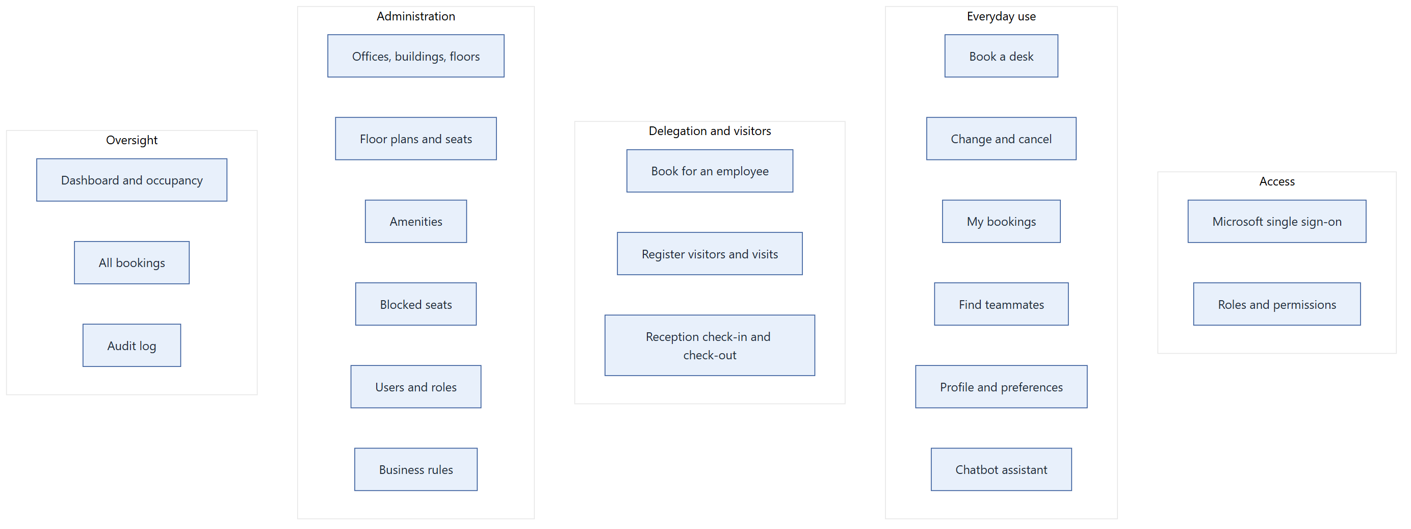
Figure: SeatBook capabilities by area.

3.2 Capability list
Area | Capability | Who | Chapter
Access | Sign in with Microsoft, stay signed in securely, sign out | All | 4
Everyday use | Dashboard with today's booking, upcoming days and teammates in the office | Employee, facilitator | 5
Everyday use | Book a desk on the floor plan | Employee, facilitator, admin | 5
Everyday use | Change a booking to another desk or day; cancel a booking | Booking owner, admin | 5
Everyday use | My bookings: current, upcoming, past, cancelled | All who book | 5
Delegation | Book a desk for a colleague, prefilled from their preferences | Facilitator, admin | 6
Visitors | Register visitor profiles; plan visits with host and optional desk | Facilitator, admin | 6
Visitors | Reception view of today's visitors; check-in and check-out | Front office | 7
Assistant | Book, change and cancel through conversation | Employees | 8
Collaboration | See which teammates are in and where; search team members | Employee, facilitator | 9
Profile | Bio, skills, preferred office, floor and amenities | All | 9
Administration | Offices (sites), buildings, floors | Admin | 10
Administration | Amenities and their categories | Admin | 10
Administration | Upload floor plans, configure seats, publish | Admin | 11
Administration | Block seats for a period | Admin | 12
Administration | Users, roles and account status | Admin | 13
Oversight | Dashboard, occupancy by period and location, activity feed | Admin | 14
Oversight | Search and manage all bookings | Admin | 14
Oversight | Audit log with filters and details | Admin | 14
Configuration | Booking windows and other organisation rules | Admin | 15
Notifications | E-mail confirmations for bookings and administrative events | Automatic | 20

Part II — Using SeatBook
Everyday features for employees, coordinators and reception.
Chapter 4 Signing In
Chapter 5 Booking a Desk
Chapter 6 Booking for Others and Visitors
Chapter 7 Front Office: Visitor Arrivals
Chapter 8 Chatbot Assistant
Chapter 9 Teammates and Profile

Chapter 4. Signing In

4.1 Overview
Users sign in with their corporate Microsoft account. There is no separate SeatBook password to create, remember or reset. Users from one partner domain sign in through the organisation's SSO gateway; SeatBook recognises their e-mail domain and routes them automatically.

4.2 How it works for the user
- Open SeatBook. The login page appears.
- Enter your work e-mail or choose Sign in with Microsoft.
- Sign in at Microsoft as usual (including multi-factor authentication if your organisation uses it).
- You arrive on your dashboard. SeatBook keeps you signed in while you work.
- Choose Sign out to end the session on that device.

4.3 What happens behind the scenes
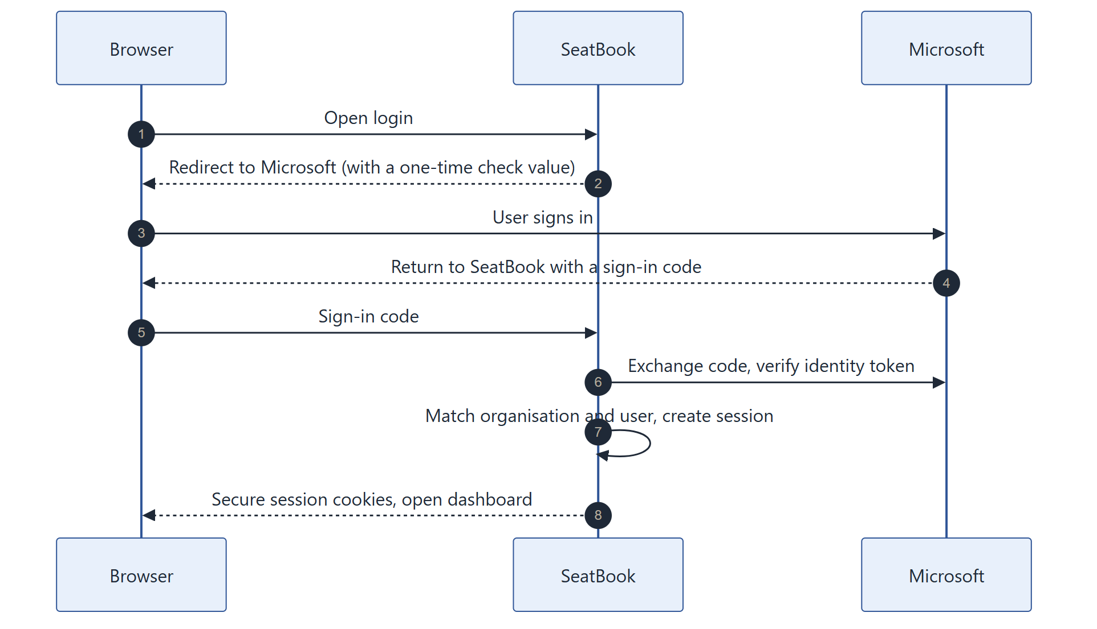
Figure: Sign-in with Microsoft.
- SeatBook verifies Microsoft's signed identity token and identifies the user's organisation from it.
- A one-time check value protects the return trip from Microsoft against tampering.
- The session lives in secure, browser-protected cookies that page scripts cannot read.
- Short-lived access is renewed silently in the background while the user is active.

4.4 Session and access control
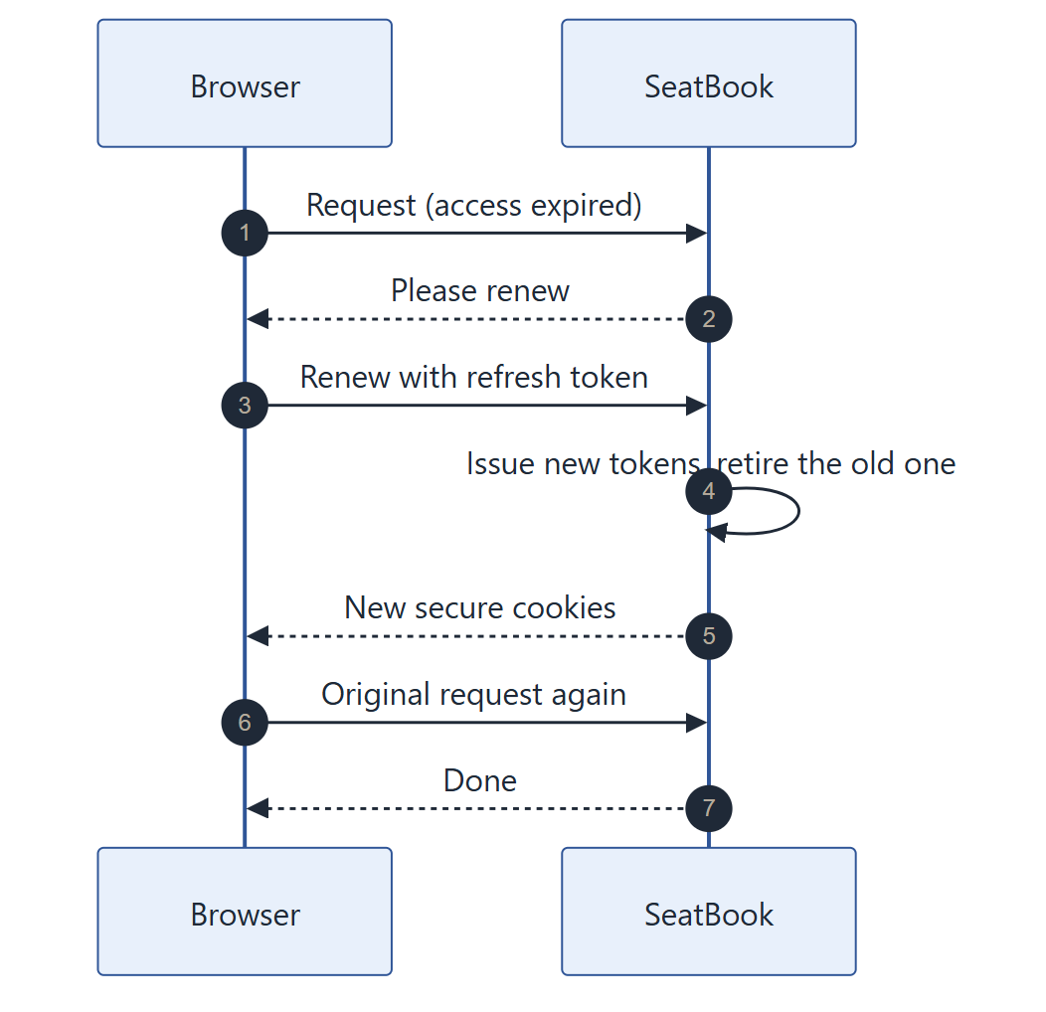
Figure: Silent session renewal.
Feature | Benefit
Single sign-on with Microsoft | No new passwords; the organisation's own sign-in policies apply
Server-side sessions | Sign-out, role changes and deactivation end access immediately
Rotating renewal tokens | A stolen old token cannot be reused; reuse ends the whole session
Account and role checked on every request | Access always reflects the user's current status
Organisation taken from the verified identity | Users only ever reach their own organisation's data
Safe sign-in errors | If sign-in cannot complete, the user returns to the login page with a short error code and no technical details

Chapter 5. Booking a Desk

5.1 Overview
Employees reserve one desk for one day on their office's interactive floor plan. They can see all their bookings, move a booking to another desk or day, and cancel it. A confirmation e-mail follows each booking.

5.2 The employee dashboard
After sign-in, employees land on a dashboard that shows:
- today's booking and where to sit;
- upcoming booked days;
- teammates who are in the office today;
- quick links to book or manage bookings.

5.3 Booking step by step
- Open Book a space.
- Choose the office (site), building, floor and date. The date picker offers only the days the organisation allows.
- The floor plan appears. Seats are coloured: available, booked, or blocked.
- Select a seat and confirm.
- SeatBook checks the request and confirms the booking on screen and by e-mail.
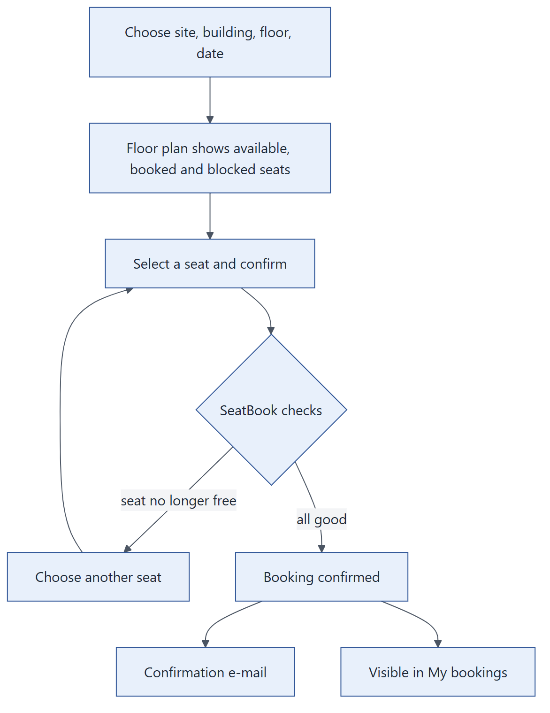
Figure: Booking a desk.

5.4 Booking rules
Rule | Purpose
One active booking per desk per day | No two people are given the same desk
One active booking per person per day | Everyone holds at most one desk a day, leaving room for others
Bookings are for today or a future day | Keeps the plan current
Bookings up to a set number of days ahead | Each organisation decides its planning horizon (for example 14 days)
Blocked desks cannot be booked | Desks under maintenance or reserved stay unavailable
Only active, bookable desks on the published floor plan | People book what actually exists in the office

5.5 Guaranteed: no double booking
When two people try to book the same desk for the same day at the same moment, SeatBook serialises the two requests: one succeeds and the other is told the desk was just taken. A second, independent safeguard in the database also refuses any duplicate. The result is that a desk is never given twice.

5.6 My bookings
My bookings groups bookings into four tabs:
Tab | Shows
Current | Today's booking
Upcoming | Future bookings
Past | Earlier bookings
Cancelled | Bookings that were cancelled

5.7 Changing a booking
Choose Change on a booking, pick a new desk or day on the floor plan, and confirm. SeatBook keeps a full history: the original booking is marked as modified and linked to the new one, so it is always clear what changed and when.

5.8 Cancelling a booking
Choose Cancel and confirm. The desk becomes available to others straight away. A booking can be cancelled up to and including its day.

5.9 Who can change or cancel
Person | Can change or cancel
The person the booking is for | ✔
The person who made the booking (for example a facilitator) | ✔
A tenant administrator | ✔ any booking in the organisation
Anyone else | —

5.10 Life of a booking
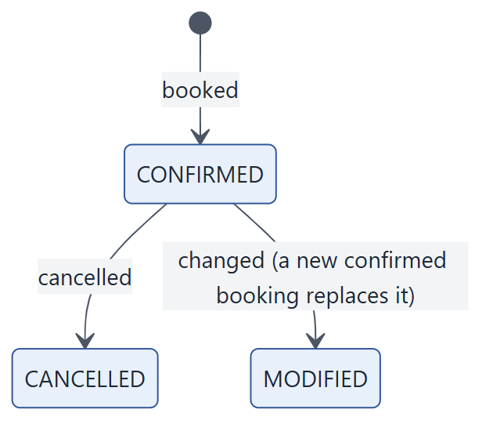
Figure: Booking states.

Chapter 6. Booking for Others and Visitors

6.1 Overview
Facilitators and tenant administrators can reserve desks for colleagues and register visitors. A visitor gets a profile, a planned visit with a host, and optionally a desk, all created together.

6.2 Two paths
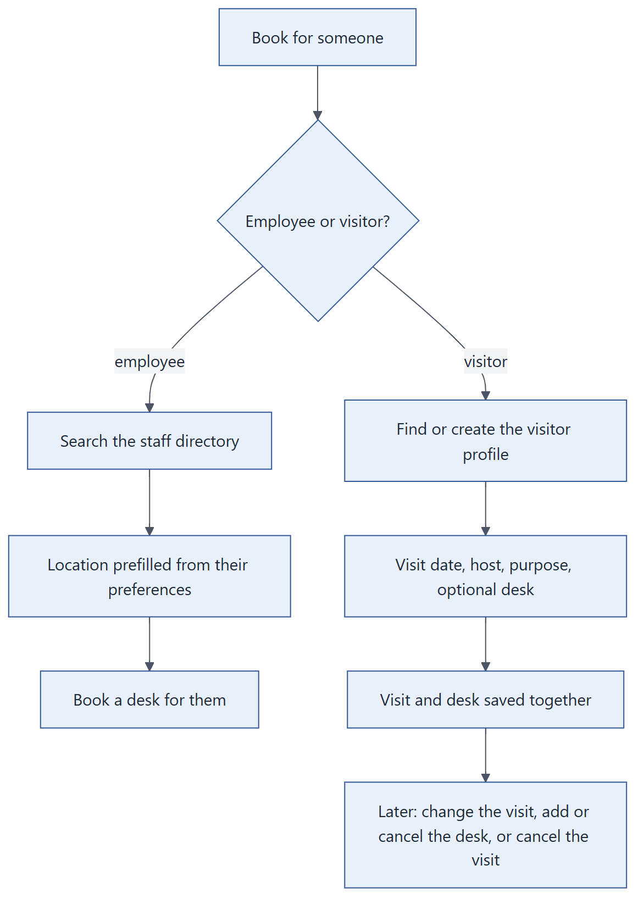
Figure: Booking for an employee or a visitor.

6.3 Booking for an employee
- Open Book for someone and choose Employee.
- Search the staff directory by name or e-mail.
- SeatBook prefills the colleague's preferred office and floor.
- Pick a desk and date on the floor plan, then confirm.
The same booking rules apply as for self-booking. The booking shows who made it and who it is for, and appears under Delegated in the facilitator's bookings.

6.4 Registering a visitor
- Choose Visitor.
- Search existing visitor profiles, or create one with name, e-mail, phone and organisation.
- Enter the visit date, the host and the purpose.
- Optionally choose a desk.
- Confirm. The visit and its desk are saved together in one step: either both are recorded or neither is.

6.5 Managing a visit afterwards
Action | Effect
Change the visit only | New date or details; desk unchanged
Change visit and desk | Both updated together
Add a desk | Reserve a desk for an existing visit
Cancel the desk | Visit stays, desk is released
Cancel the visit | Visit and any desk are cancelled

6.6 Visitor information quality
- Phone numbers are stored in international format.
- Each visitor e-mail address is held by one active profile per organisation, so the same visitor is not registered twice.
- Visit dates are planned within the organisation's visitor booking window.

6.7 Benefits
- Coordinators arrange attendance for teams, new joiners and guests in minutes.
- Reception receives an accurate list of who is coming, with host and desk.
- Every delegated booking records both the coordinator and the beneficiary.

Chapter 7. Front Office: Visitor Arrivals

7.1 Overview
Reception staff have their own dashboard focused on the current day: who is expected, who has arrived and who has left. Checking a visitor in or out takes one click.

7.2 Daily workflow
- Sign in. The front-office dashboard opens automatically.
- Select the office (site).
- The visitor table lists today's visits with host, purpose, desk and status, and summary counts at the top.
- When a visitor arrives, choose Check in.
- When they leave, choose Check out.
- Open a visitor to see their booking details.

7.3 Visit status
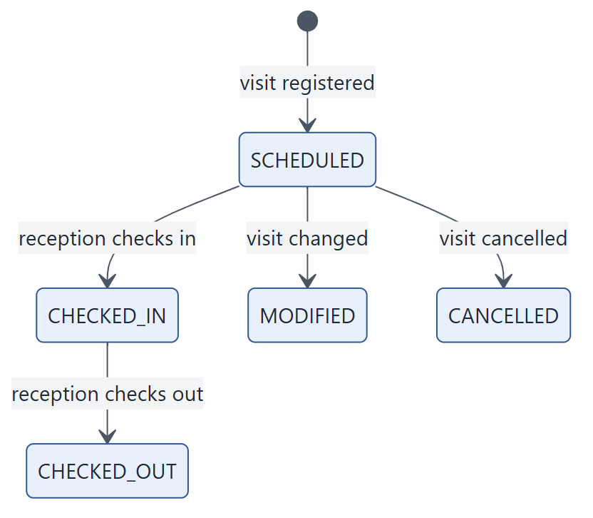
Figure: Life of a visit.

7.4 Built-in safeguards
Safeguard | Benefit
Only front office records arrivals and departures | An independent, reliable on-site record; hosts and coordinators cannot mark their own visitors as arrived
Reception sees the current day only | Visitor information is shared on a need-to-know basis
Each step happens once | A visitor cannot be checked in twice; check-out follows check-in
Every action is recorded | The audit log shows who checked each visitor in and out, and when

Chapter 8. Chatbot Assistant

8.1 Overview
SeatBook includes a conversational assistant, opened from a floating button on every page. Employees can book, view, change and cancel desks by choosing from menus or typing in plain language, for example "book a desk tomorrow on floor 3".
Each organisation decides whether the assistant is shown to its employees (see Chapter 15).

8.2 What it can do
Request | Example
Book a desk | "Book me a desk next Monday in the main office"
See bookings | "What have I booked this week?"
Change a booking | "Move tomorrow's booking to floor 2"
Cancel a booking | "Cancel my booking on Friday"
Get help | Menu of available actions

8.3 How a message is handled
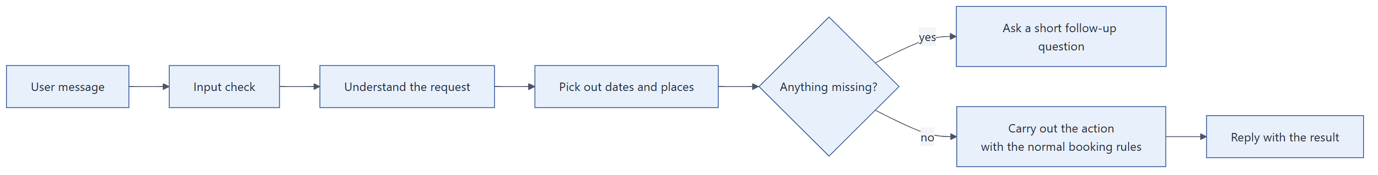
Figure: How the assistant processes a message.

8.4 Design strengths
- Same rules as the app. The assistant uses the same booking services as the screens, so availability, permissions and audit records are identical.
- No extra sign-in. It uses the user's existing SeatBook session.
- Predictable. It is rule-based rather than generative: it understands a defined set of requests and always asks when information is missing.
- No external AI service. Conversations stay within SeatBook; sessions and messages are stored per user and organisation.

Chapter 9. Teammates and Profile

9.1 Find teammates
Coming to the office is often about meeting colleagues. Find teammates shows:
- members of your team and how many are in the office today;
- where each teammate is sitting;
- a search across team members by name.
This makes it easy to choose days and desks near the people you work with.

9.2 Profile and preferences
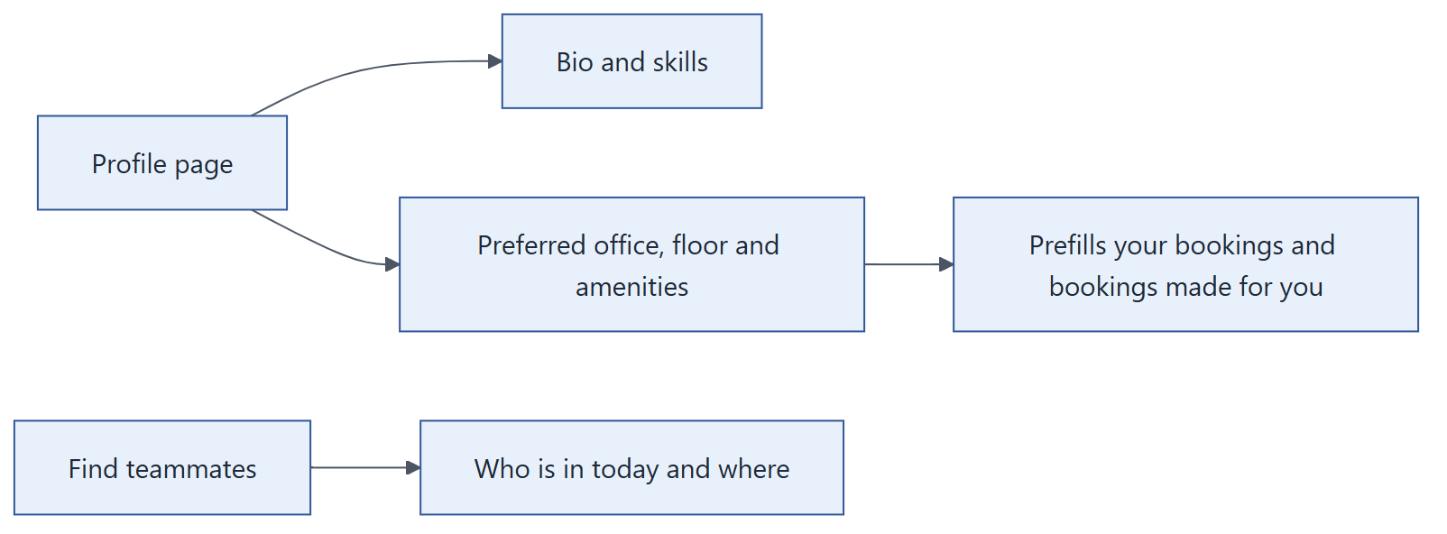
Figure: Profile, preferences and teammates.
Section | What you can set | Used for
About me | Short bio and skills | Helps colleagues know who you are
Work preferences | Preferred office, building and floor | Prefills the booking screen; facilitators booking for you start from your preference
Preferred amenities | For example a second monitor or a standing desk | Helps you and your coordinator choose a suitable desk
Booking history | Your past bookings | Personal record

Part III — Administration
Setting up offices, floor plans, desks, users and rules, and overseeing activity.
Chapter 10 Offices, Buildings, Floors and Amenities
Chapter 11 Floor Plans and Seats
Chapter 12 Blocking Seats
Chapter 13 Users and Roles Administration
Chapter 14 Dashboard, Booking Oversight and Audit Log
Chapter 15 Configuration: Business Rules

Chapter 10. Offices, Buildings, Floors and Amenities

10.1 Overview
Administrators describe their real estate in SeatBook as a simple hierarchy. Every desk, floor plan and booking belongs to a place in it.
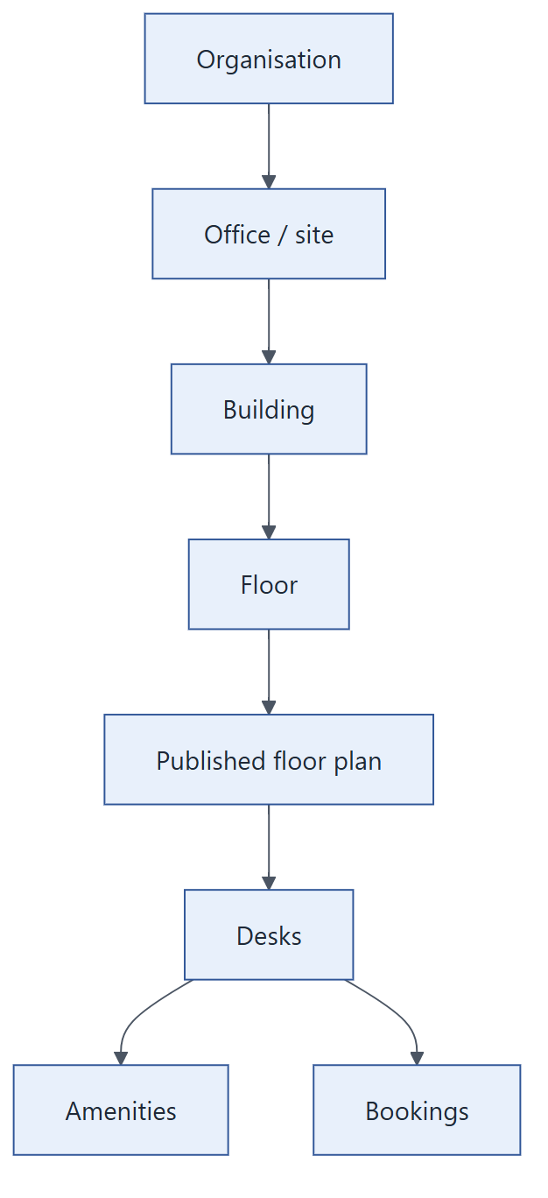
Figure: The location hierarchy.

10.2 Managing locations
Screen | What administrators do
Offices | Add and edit sites: code, name, city, country, time zone, status
Buildings | Add and edit buildings within a site
Floors | Add and edit floors within a building

Locations can be marked inactive when no longer in use, keeping their history intact. Names are checked for duplicates within their parent location, and every change is recorded in the audit log with the fields that changed.

10.3 Amenities
Amenities describe what a desk offers, such as a docking station, two monitors or a height-adjustable desk. They are grouped into categories.
Use | Benefit
Assigned to desks when configuring a floor plan | Employees see what each desk offers
Chosen as personal preferences | Employees and their coordinators find suitable desks faster
Shown on the booking screen | Informed choice of desk

Chapter 11. Floor Plans and Seats

11.1 Overview
Each floor's layout is an SVG drawing, typically exported from the facilities team's own design tools. Administrators upload it, SeatBook finds the desks in it, the administrator configures them, and the plan is published for booking. Layouts are versioned, so the office can be re-arranged without losing history.

11.2 Workflow
- Upload. Choose the office, building and floor and upload the drawing. A preview is shown.
- Desks are detected. SeatBook reads the desk shapes from the drawing and lists them.
- Configure desks. Give each desk its code, mark it bookable or not, and assign amenities, one by one or in bulk.
- Publish. Make the layout live immediately, or prepare it with a planned effective date that respects the organisation's notice period.
- Book. Employees now see and book desks on the new plan.
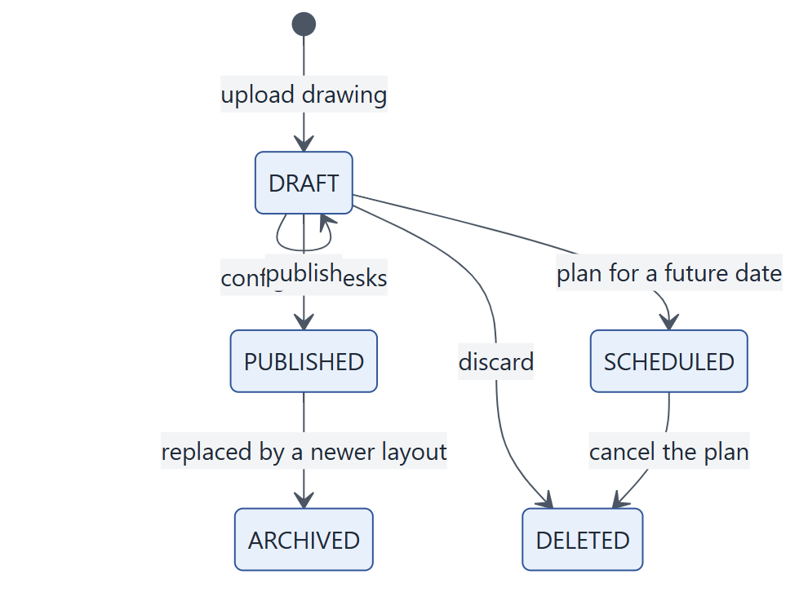
Figure: Life of a floor layout.

11.3 Strengths
Feature | Benefit
Uses the office's own drawing | Employees recognise the real floor; no manual redrawing
Automatic desk detection | Fast set-up of large floors
Bulk configuration | Codes, bookability and amenities for many desks at once
One live layout per floor | Everyone books on the same, current plan
Version history | Previous layouts are archived, not lost
Notice period for planned changes | Staff get time to adjust to a re-arranged floor
Private file storage | Drawings are stored privately per organisation and shown through short-lived secure links
Upload notification | Administrators are informed by e-mail when a new layout is uploaded

Chapter 12. Blocking Seats

12.1 Overview
Administrators can take desks out of use for a period, for maintenance, an event or a reserved area, without changing the floor plan. Blocked desks are shown as unavailable on the booking screen.

12.2 Workflow
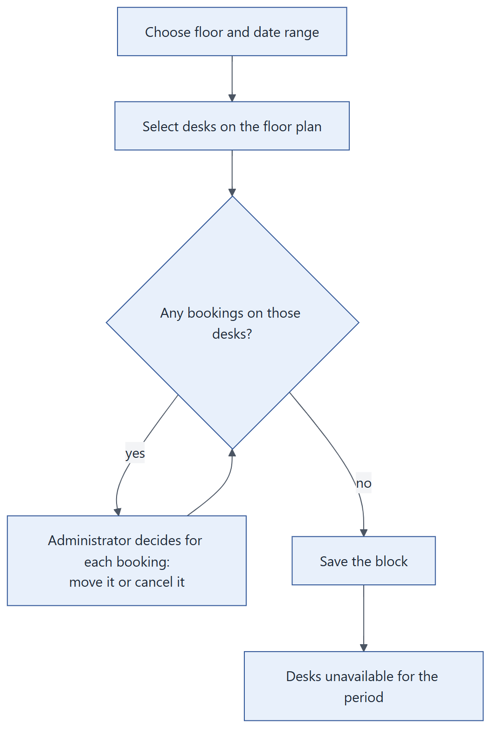
Figure: Blocking desks without surprising anyone.
- Open Blocked seats → Block and choose the floor and dates.
- Select desks on the floor plan.
- If people have already booked those desks, SeatBook lists the bookings so the administrator can move or cancel each one deliberately.
- Save. The block becomes active for the chosen period.
- Edit the dates or end the block early at any time; each block keeps a history.

12.3 Overview screen
Blocks are grouped so administrators see what needs attention:
Group | Meaning
Active | In effect now
Upcoming | Starting soon
Expiring soon | Ending soon
Expired | Recently ended

The time windows for these groups, and how far ahead a block may start, are organisation settings (Chapter 15).

12.4 Strengths
- No silent cancellations. Existing bookings are never overridden without the administrator's decision.
- Layout aware. Blocks always refer to desks on the floor plan in force for the period.
- History. Every block keeps a record of changes.

Chapter 13. Users and Roles Administration

13.1 Overview
Users are created automatically the first time they sign in with their Microsoft account. Administrators then manage their role and account status.

13.2 Workflow
- Open Users. Search and filter by role and status.
- Open a user and choose Change role.
- Select the new role and/or status and save.
- The change applies immediately: the user's open sessions end and their next sign-in carries the new role.
The Roles screen lists the roles and who holds them.

13.3 Built-in protections
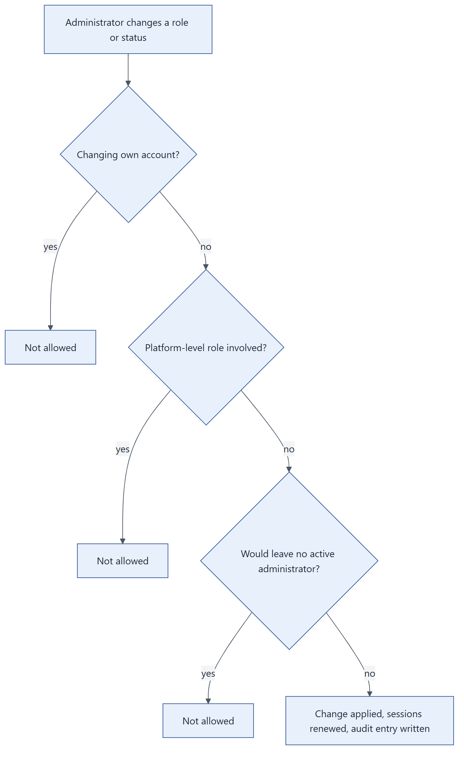
Figure: Safeguards on access changes.
Protection | Benefit
No self-changes | Administrators cannot raise or lower their own access
At least one active administrator | An organisation can never lock itself out
Platform roles protected | Organisation administrators cannot assign or alter platform-level roles
Immediate effect | Removed access is removed now, not at the next sign-in
Full audit | Every change records the before and after values and who made it

Chapter 14. Dashboard, Booking Oversight and Audit Log

14.1 Overview
Administrators have three oversight tools: a dashboard of occupancy and activity, a searchable list of every booking in the organisation, and the audit log.
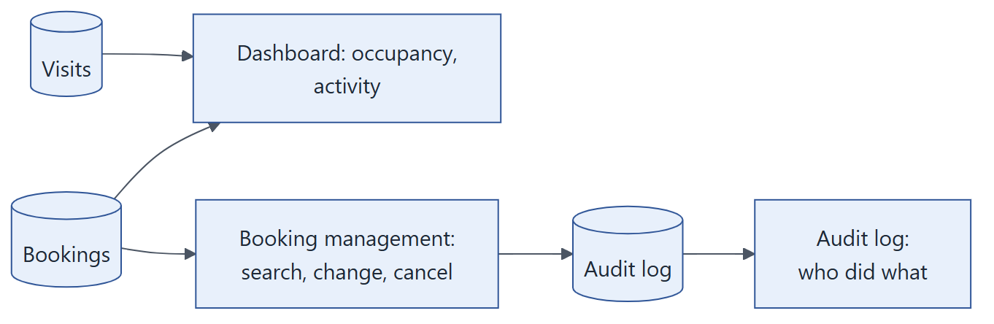
Figure: Data behind the administrator screens.

14.2 Dashboard
View | Shows
Summary cards | Offices, buildings, floors and desks; bookings and visitors today; desks booked and blocked; occupancy and utilisation percentages
Occupancy over a date range | Bookings per day across the chosen period
Occupancy by location | Office, building and floor comparison, for example the busiest offices
Activity feed | Latest bookings and visits with people and places

14.3 Booking management
- Search all bookings by date, location, person, desk, status and type (employee or visitor).
- Suggestions while typing names and desk codes.
- Change or cancel any booking, and manage visits, using the same steps and rules as employees and facilitators.

14.4 Audit log
The audit log is the organisation's record of significant actions: sign-ins, bookings, changes, cancellations, visitor check-ins, location and layout changes, blocked seats and access changes.
Capability | Detail
Filters | Action, area, item type, result (success, denied, failure), date range or "last N seconds"
Search and sort | Free-text search; sort by time and other columns
Detail view | Who, when, from where, what changed (before and after), and a request reference
Includes refusals | Attempts that were not allowed are recorded too, not only successful actions

Chapter 15. Configuration: Business Rules

15.1 Overview
Each organisation sets its own policies on the Configuration screen. Changes take effect for all users on their next action, without any software change or deployment.

15.2 Available settings
Group | Setting | Effect
Booking | Employee booking window (days ahead) | How far into the future employees may book
Booking | Visitor booking window (days ahead) | How far ahead visits and visitor desks may be planned
Floor plans | Notice period (days) | Minimum notice before a planned layout change
Floor plans | Visibility of draft, archived and deleted layouts (days) | How long non-live layouts stay listed for administrators
Blocked seats | Maximum days ahead for a block | How far ahead desks may be blocked
Blocked seats | Upcoming, expiring-soon and expired windows | How blocks are grouped on the overview screen
Activity | Number of activity entries | Length of the dashboard activity feed
Assistant | Show the chatbot to employees | Turns the assistant on or off for employees

15.3 How settings work
- Every setting has a sensible default; an organisation only overrides what it needs.
- Values are validated (for example, a booking window must be at least one day).
- Booking screens read the current settings, so the date picker always matches the policy.

Part IV — Technology
How SeatBook is built, secured, integrated, tested and operated.
Chapter 16 System Architecture
Chapter 17 Technical Design Highlights
Chapter 18 Data Model
Chapter 19 Security and Data Protection
Chapter 20 Integrations and Notifications
Chapter 21 API Overview
Chapter 22 Quality Assurance
Chapter 23 Deployment and Operations

Chapter 16. System Architecture

16.1 Architecture at a glance
Aspect | Choice
Style | Single-page web application with one stateless REST API (modular monolith)
Frontend | Next.js 15, React, TypeScript, Tailwind CSS, hosted on AWS Amplify
Backend | Python 3.14, FastAPI, PostgreSQL access through parameterised SQL, Pydantic data validation
Runtime | AWS Lambda behind Amazon API Gateway (HTTP API)
Database | PostgreSQL on Amazon RDS in private network subnets
Identity | Microsoft Entra ID single sign-on; organisational SSO gateway for one partner domain
Files | Floor-plan drawings in a private Amazon S3 bucket, delivered through short-lived signed links
E-mail | Amazon Simple Email Service (SES)
Assistant | Rule-based chatbot running inside the API and reusing its business services
Multi-tenancy | One platform, many organisations; every record carries its organisation, taken from the verified identity
Region | AWS Asia Pacific (Mumbai), ap-south-1

16.2 System context
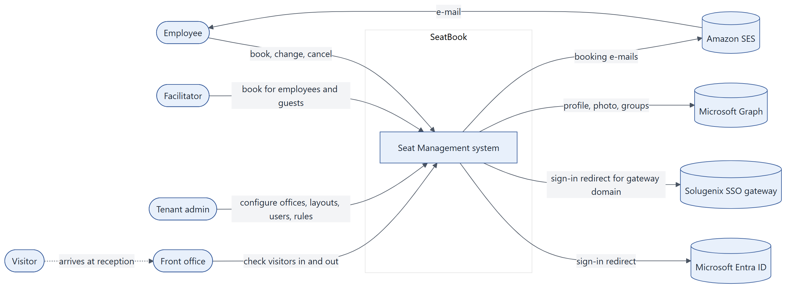
Figure: SeatBook and the people and systems around it.

16.3 Containers
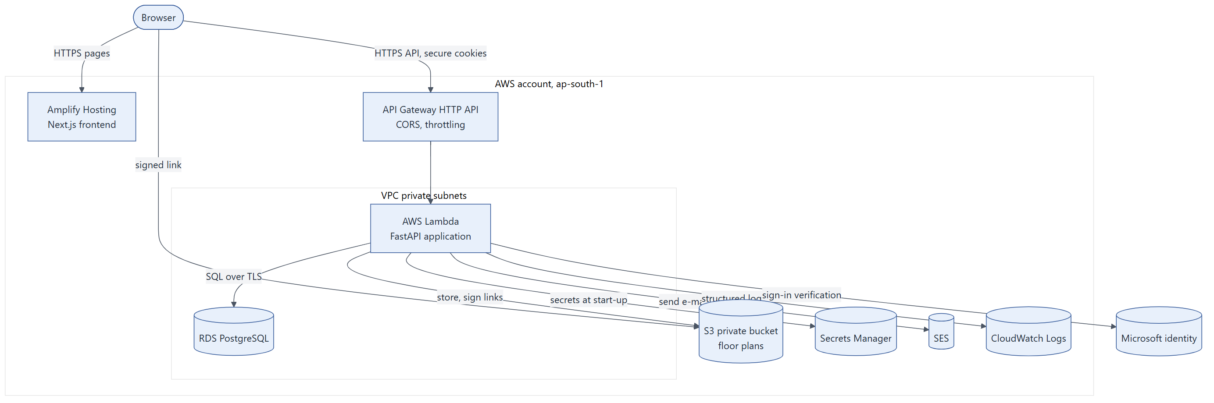
Figure: Deployed building blocks on AWS.
Container | Responsibility
Frontend (Amplify) | All screens; role-based navigation; talks to the API over HTTPS with secure cookies
API (Lambda) | Business logic, access control, persistence, e-mail, file handling, chatbot
Database (RDS) | System of record for organisations, users, locations, layouts, bookings, visits, settings and audit
Object storage (S3) | Floor-plan drawings, stored per organisation
Secrets Manager | Database credentials and signing keys, never stored in code
CloudWatch | Application and gateway logs

16.4 Backend components
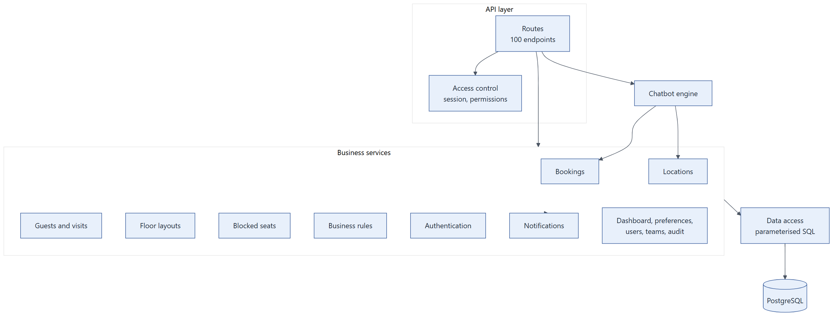
Figure: Inside the API.
Clear layering. Routes handle web requests and access gates; business services own rules, transactions and audit records; the data-access layer owns the SQL. The chatbot is a second entry point into the same services, so it follows exactly the same rules.

16.5 Key flows

16.5.1 Booking a desk
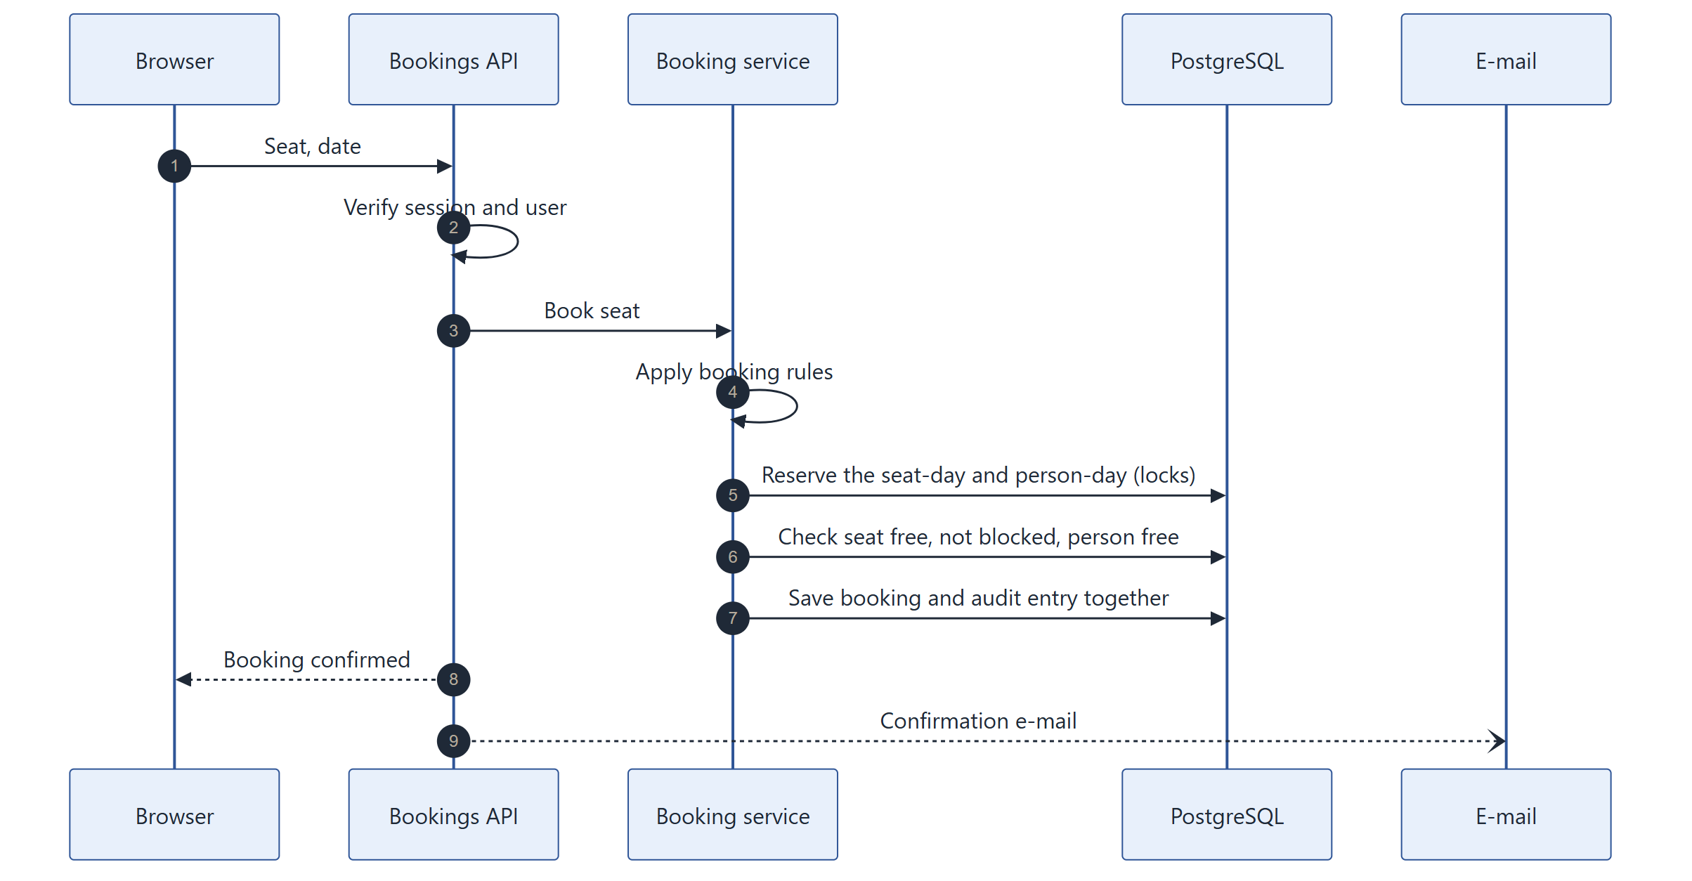
Figure: How a booking is made safely.

16.5.2 Deployment pipeline
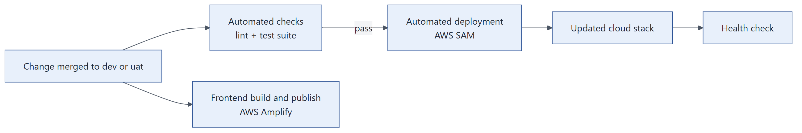
Figure: From code change to running system.

16.6 Quality attributes
Attribute | How SeatBook achieves it
Security | Corporate single sign-on, server-side sessions, permission checks on every request, organisation isolation, encrypted connections, secrets in a vault
Consistency | Each action is one database transaction; locking and unique constraints prevent double booking
Scalability | Serverless compute scales with demand within a controlled limit that protects the database
Availability | Fully managed AWS services (Lambda, API Gateway, RDS, S3, Amplify); gateway throttling smooths traffic spikes
Observability | Structured logs with request, organisation and user identifiers; gateway access logs; business audit log
Maintainability | Clear layering, typed frontend, automated tests and deployment
Cost efficiency | Pay-per-use serverless compute and managed hosting

16.7 Design decisions
Decision | Rationale
Serverless API on Lambda | Low operational overhead, automatic scaling, one deployable unit
Direct, parameterised SQL | Full control over locking and reporting queries; efficient and safe
Secure cookie sessions | Tokens are never exposed to page scripts
Shared database with organisation keys | Simple operations; every query is scoped to the organisation
Rule-based assistant inside the API | Predictable behaviour, no external AI dependency, reuse of proven business services
Floor plans as SVG drawings | Uses the facilities team's own drawings; crisp on every screen size

Chapter 17. Technical Design Highlights

17.1 Request handling
Every API request follows the same path:
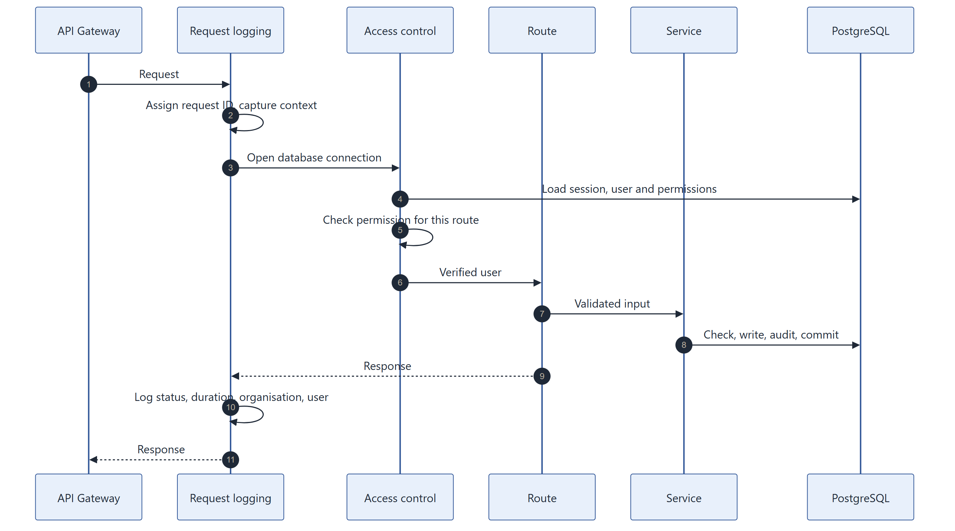
Figure: Life of an API request.
Step | Detail
Identity | The session cookie is verified, the session is confirmed active, and the user and permissions are reloaded
Access | Route-level permission gates, plus business rules such as "only the booking owner or an administrator"
Validation | Every input is validated against a typed schema before any processing
Transaction | Business services perform all checks and writes, including the audit entry, in one transaction
Errors | Responses use clear, stable error codes (for example seat taken or not found) without internal details

17.2 Data consistency
Mechanism | Guarantee
Single transaction per action | An action is fully applied or not at all
Booking slot locks | Requests for the same desk-day or person-day are handled one at a time
Unique database constraints | A second, independent guarantee of one booking per desk-day and person-day
Booking history | Changes create a linked new booking; nothing is overwritten
Audit within the transaction | The record of an action is saved together with the action

17.3 Organisation settings
Settings have a platform default and an optional organisation value. Services read the effective value when they need it, so a change made on the Configuration screen applies on the next action.

17.4 Floor-plan pipeline
Figure: From drawing to bookable floor.

17.5 Notifications
E-mails are rendered from templates (with automatic escaping of user-provided text) and sent through Amazon SES after the action completes. Temporary e-mail service hiccups are retried automatically with increasing delays. Delivery problems are logged and never affect the booking itself.

17.6 Logging and traceability
Signal | Content
Application log | One structured entry per request: request ID, method, path, status, duration, organisation, user
Gateway access log | Request ID, route, status
Audit log | Business actions with actor, outcome, before and after values
Correlation | Callers can pass a correlation ID, which appears in the logs

Chapter 18. Data Model

18.1 Overview
SeatBook stores its data in PostgreSQL: 36 tables in four domains. Every business record carries the organisation it belongs to.
Domain | Main tables
Identity and access | Organisations, users, identities, sessions, roles, permissions, teams
Locations and layouts | Sites, buildings, floors, floor layouts, desk mappings, desks, amenities
Bookings and visitors | Bookings, blocked seats, visitors, visits
Configuration and records | Business rules and organisation values, preferences, audit log, chatbot sessions and messages

18.2 Core model
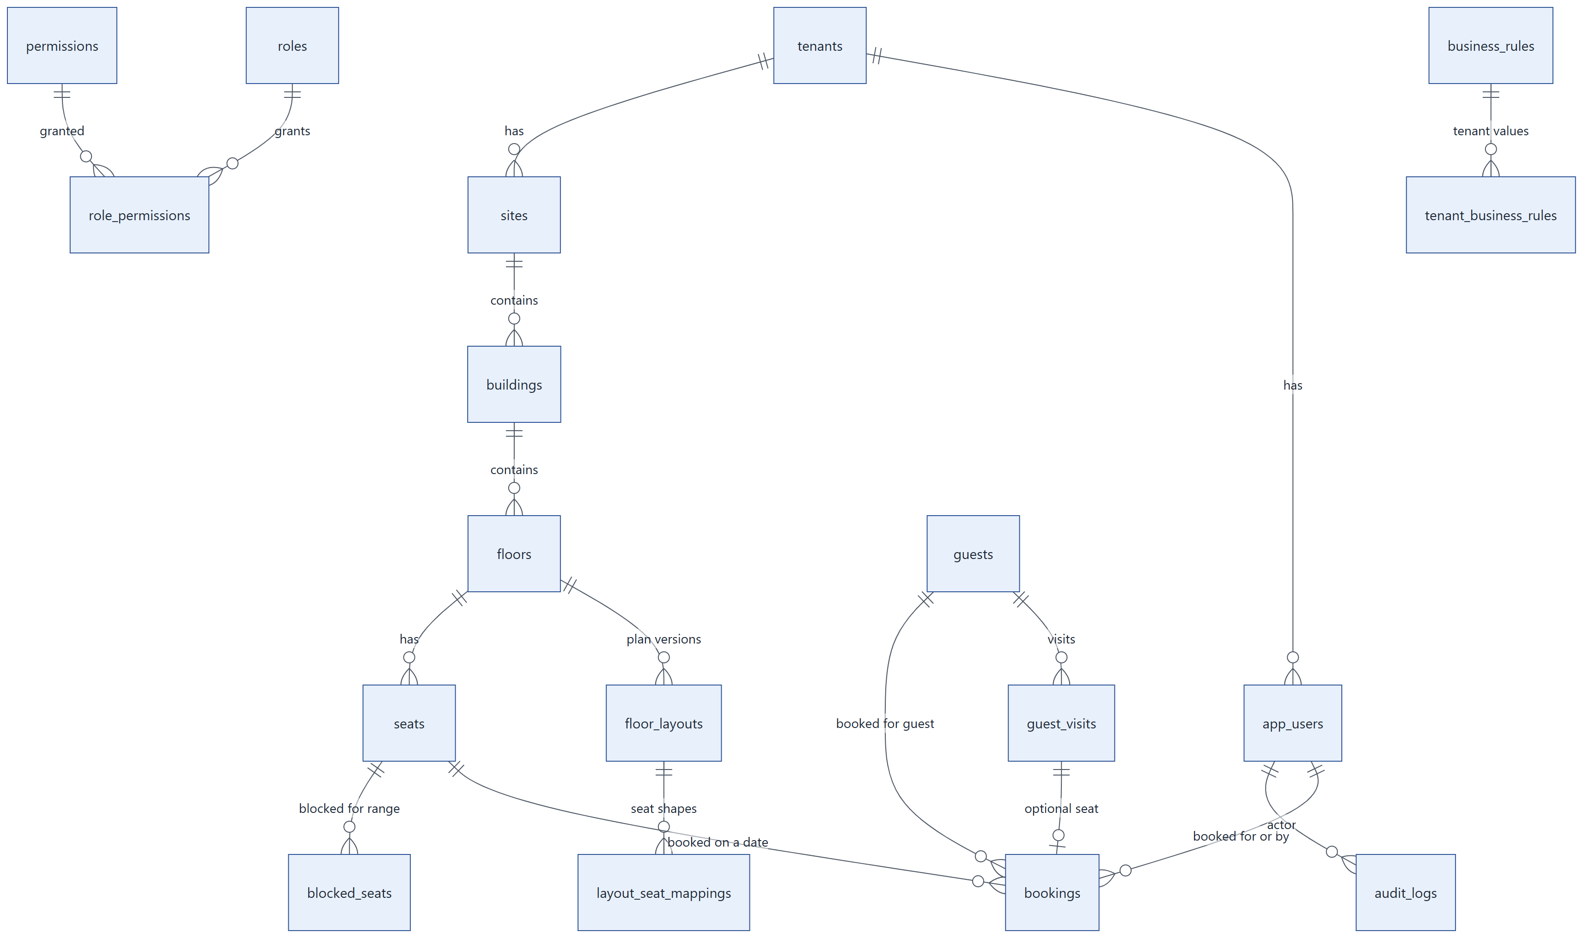
Figure: The core entities and how they relate.

18.3 Key entities
Entity | Holds
Organisation (tenants) | A customer organisation and its Microsoft tenant
User (app_users) | Name, e-mail, role, status, profile
Site, building, floor | The location hierarchy
Floor layout | A version of a floor's drawing and its status
Desk (seats) | A bookable place on a published layout, with its amenities
Booking | One desk, one day, for an employee or a visitor, with who booked it and its status
Visitor (guests) and visit | Visitor profile and planned visits with host and status
Blocked seat | A desk taken out of use for a period
Business rule | A setting's default and each organisation's value
Audit log | Who did what, when, with what outcome and which changes

18.4 Integrity rules built into the database
Rule | Mechanism
One active booking per desk per day | Unique index on organisation, desk and date for active bookings
One active booking per employee per day | Unique index on organisation, employee and date
One active booking per visitor per day | Unique index on organisation, visitor and date
One published layout per floor | Unique index on floor for published layouts
One planned layout per floor | Unique index on floor for scheduled layouts
One active visitor profile per e-mail | Unique index on organisation and lower-cased e-mail
Referential integrity | Foreign keys link related entities such as desks, bookings, visits and users

18.5 Domain diagrams

18.5.1 Locations and layouts
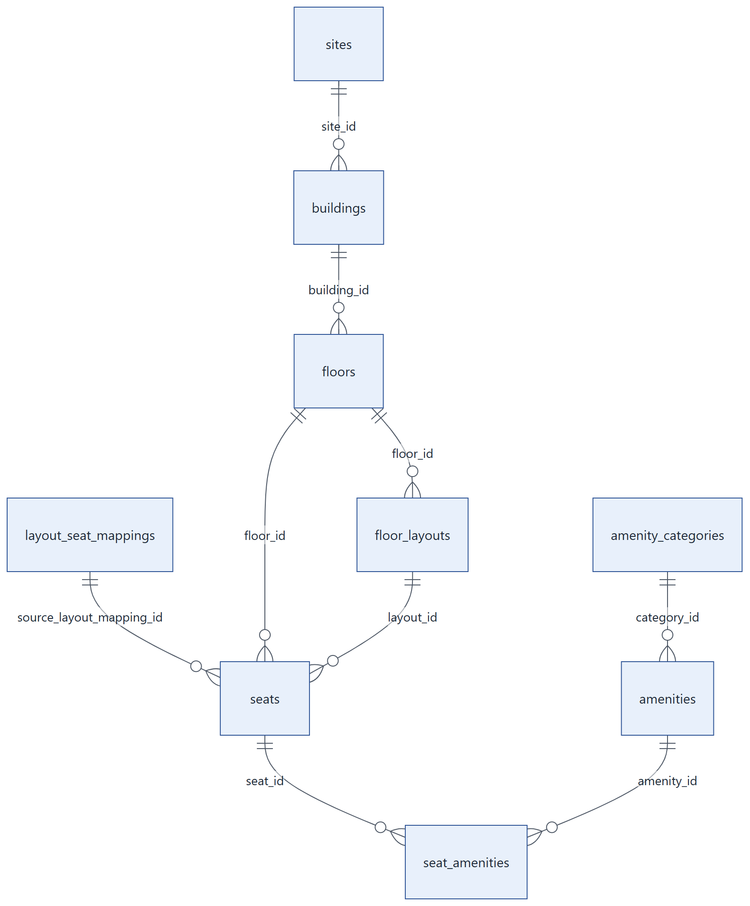
Figure: Locations and layouts.

18.5.2 Bookings and visitors
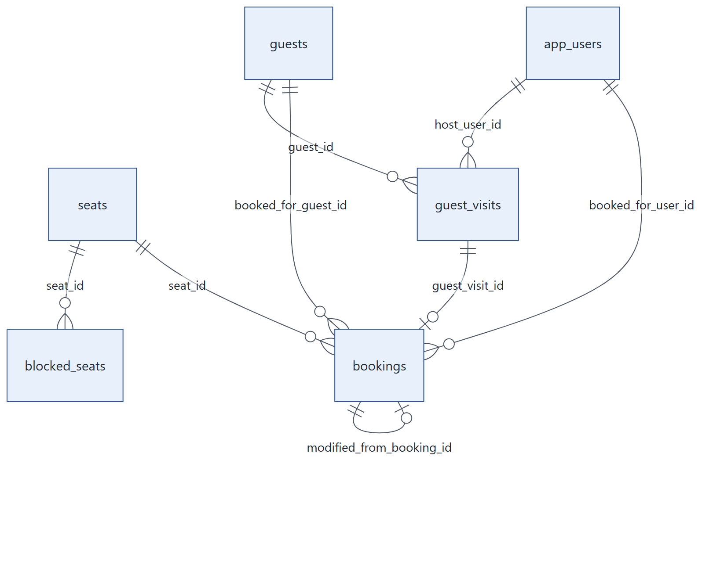
Figure: Bookings and visitors.

Chapter 19. Security and Data Protection

19.1 Security by design
SeatBook protects access and data at several layers, from sign-in to the database.
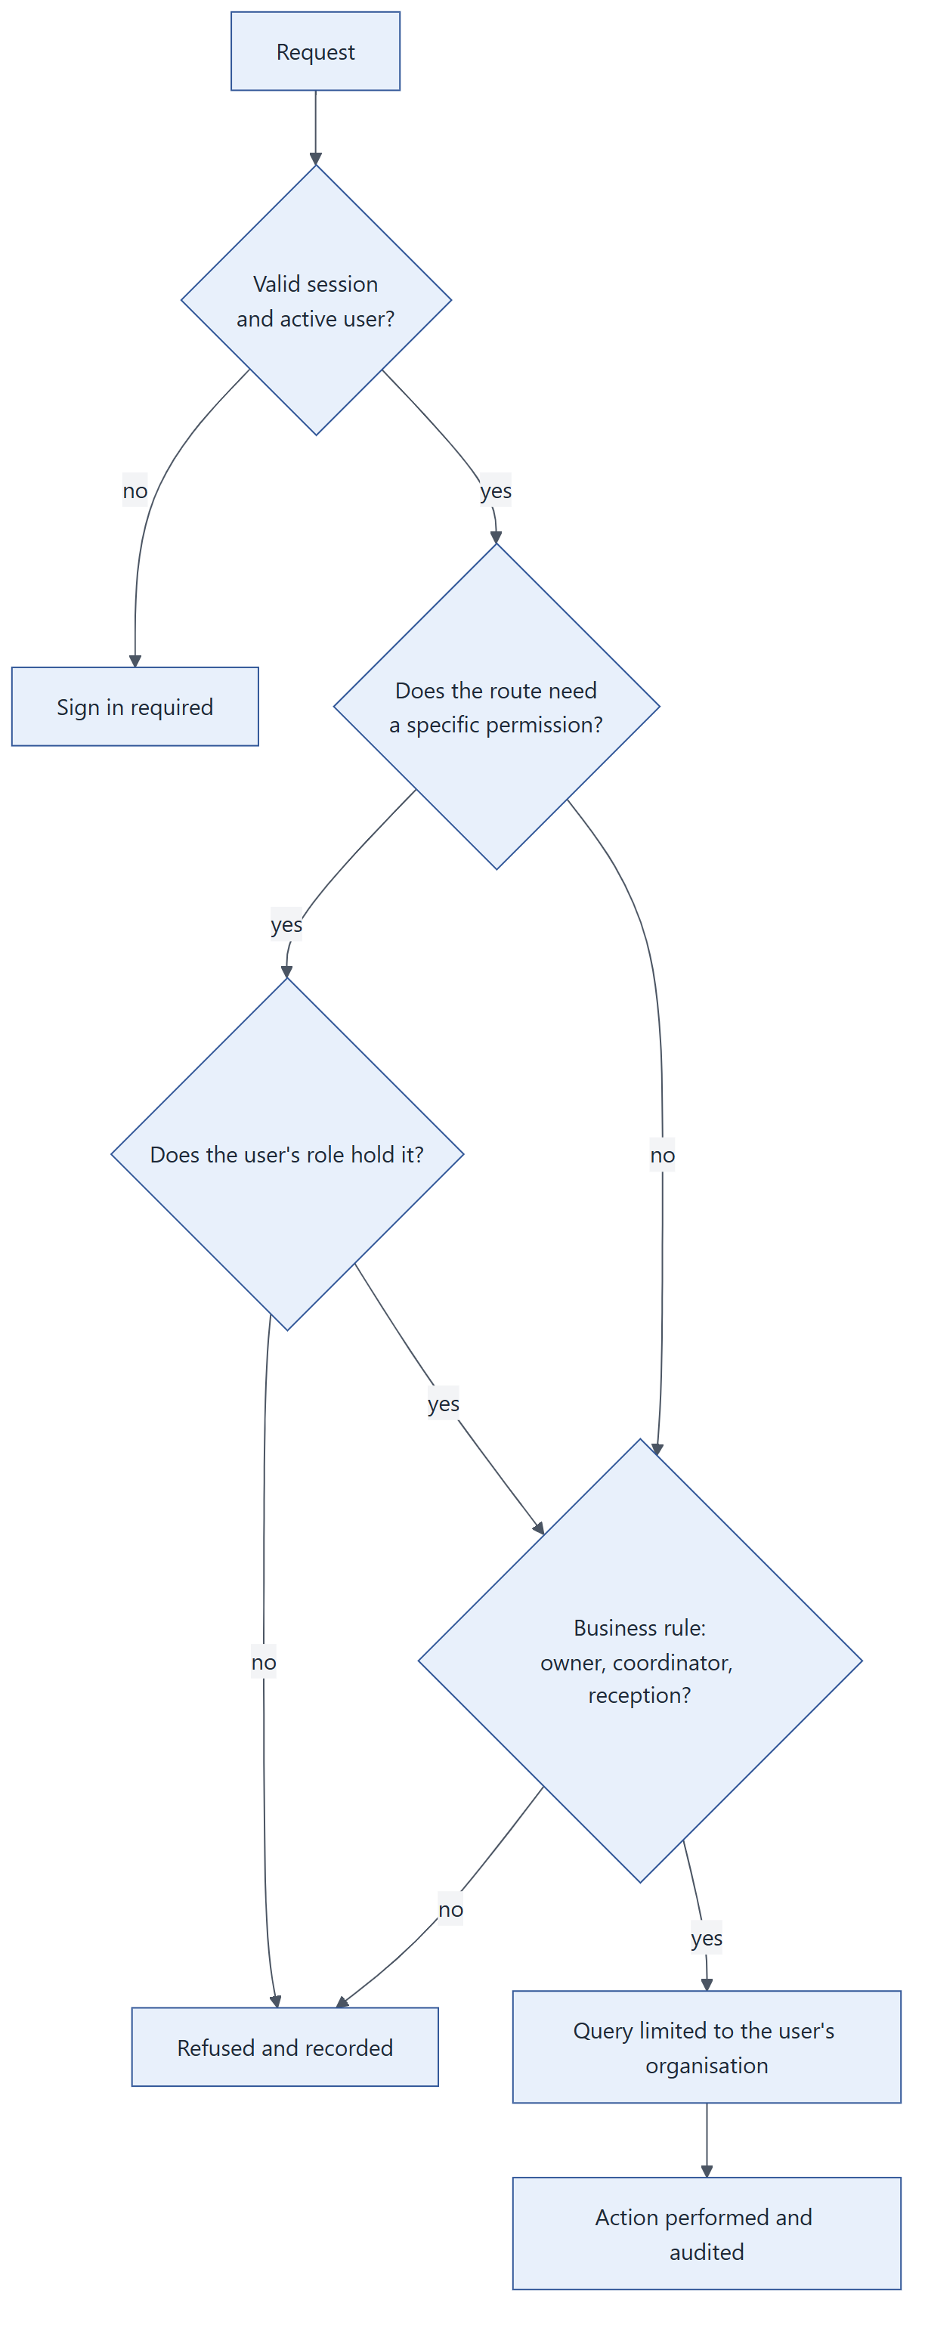
Figure: How every request is checked.

19.2 Identity and sessions
Control | Detail
Corporate single sign-on | Microsoft Entra ID; SeatBook never stores passwords
Verified identity | Microsoft's signed identity token is verified; the user's organisation comes from it
Protected sign-in round trip | A one-time check value guards the return from Microsoft
Secure cookies | Session tokens are kept in HttpOnly, Secure cookies that page scripts cannot read
Short-lived access | Access tokens last 15 minutes and are renewed silently
Rotating renewal | Each renewal issues a new token; reuse of an old one ends the session
Server-side sessions | Sign-out, role change and deactivation end access immediately

19.3 Access control
Control | Detail
Authentication on every request | All 93 non-public API endpoints require a valid session of an active user
Role-based permissions | Administrative functions require specific permissions held by the user's role
Ownership rules | Bookings can be changed only by the person they are for, the person who made them, or an administrator
Delegation rules | Only facilitators and administrators book for others or manage visitors
Separation of duties | Only front office records visitor arrivals and departures
Self-protection | Administrators cannot change their own access; an organisation always keeps an administrator

19.4 Organisation isolation
- The organisation is taken from the verified identity, never from what the browser sends.
- Every database query is limited to the user's organisation.
- Floor-plan files are stored under a separate folder per organisation.

19.5 Protecting data
Area | Control
In transit | HTTPS for the website and API; TLS between the API and the database
Network | API and database run in private network subnets; the database is not publicly reachable
Secrets | Database credentials and signing keys live in AWS Secrets Manager, not in code
Files | Private storage; files are shown through signed links that expire
Input | Every request is validated against a typed schema; database access uses parameterised queries
Output | Errors use short codes without internal details; e-mail templates escape user-provided text
Least privilege | The application's cloud role may only read its two secrets, store and read floor plans, and send e-mail
Deployment | Automated deployments use short-lived federated credentials (OIDC); no long-lived cloud keys
Traffic limits | The API gateway throttles excessive request rates

19.6 Audit and accountability
Every significant action writes an audit entry with the actor, organisation, action, item, outcome, before and after values, changed fields, request ID, IP address and browser. Successful, refused and failed actions are all recorded, giving administrators a complete picture.

Chapter 20. Integrations and Notifications

20.1 External services
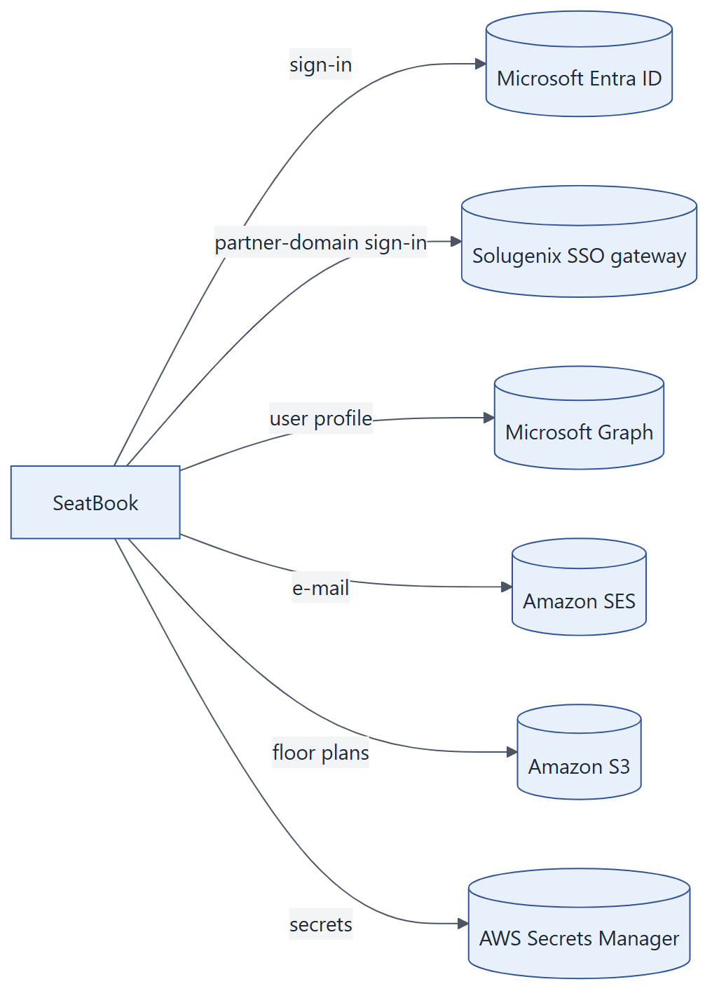
Figure: Services SeatBook works with.
Service | Used for
Microsoft Entra ID | Single sign-on with corporate accounts
Solugenix SSO gateway | Sign-in for users of the configured partner e-mail domain
Microsoft Graph | User profile details at sign-in
Amazon SES | Booking and administrative e-mails
Amazon S3 | Private storage of floor-plan drawings
AWS Secrets Manager | Credentials and keys

20.2 E-mail notifications
Event | Recipients
Desk booked, changed or cancelled | The people concerned by the booking
Floor layout uploaded or published | All administrators of the organisation, plus any configured notification addresses
Seats blocked | All administrators of the organisation, plus any configured notification addresses

E-mails are built from branded templates and sent after the action is complete. Short service interruptions are retried automatically. An e-mail problem never affects the booking itself.

20.3 Onboarding a new organisation
- Register the organisation's Microsoft tenant in SeatBook.
- Users sign in with their Microsoft accounts and are created automatically.
- An administrator sets up offices, uploads floor plans, configures desks, and assigns roles.
- Optional: adjust business rules on the Configuration screen.

Chapter 21. API Overview

21.1 Overview
The SeatBook frontend talks to one REST API with 100 endpoints. All endpoints exchange JSON over HTTPS, except floor-plan uploads, which send the file itself. Apart from sign-in, sign-out and health checks, every endpoint requires a signed-in user.
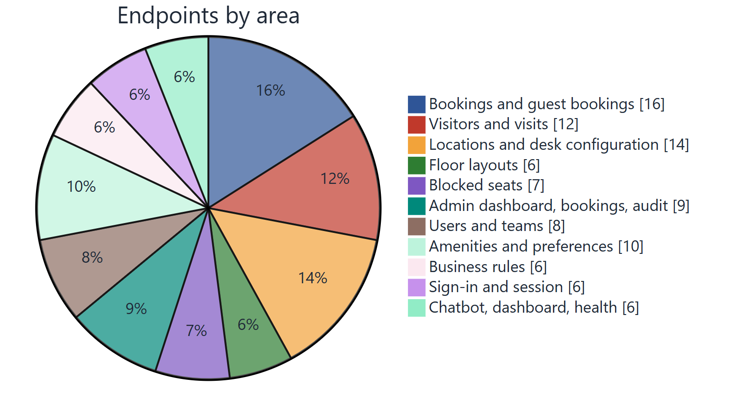
Figure: How the 100 endpoints are distributed.

21.2 Endpoint groups
Area | Endpoints | Examples
Sign-in and session | 6 | Start sign-in, Microsoft and gateway return, current user, renew, sign out
Bookings | 12 | Book, check eligibility, change, cancel; my bookings by period; bookings made for others
Guest bookings | 4 | List, view, change, cancel visitor desks
Visitors | 6 | Search, create, view and update visitor profiles; status; visit history
Visits | 6 | Create visits (with optional desk), list, view, check in, check out, manage
Offices, buildings, floors | 12 | List, create, view and update each level; desks on a floor
Desk configuration | 2 | Configure one desk or many desks at once
Floor layouts | 6 | Upload, list per floor, desks in a layout, publish, schedule, discard
Blocked seats | 7 | List, summary, floor resources, block, update, end, history
Admin bookings | 3 | Search all bookings; suggestions for people and desks
Admin dashboard | 4 | Summary, occupancy by date range and by location, activity
Audit log | 2 | Search and detail
Users and access | 6 | Directory, user detail and bookings, profile update, role and status change
Teams | 2 | My team overview, member search
Amenities and categories | 8 | List, create, view and update
Preferences | 2 | Save mine; read a colleague's (for booking on their behalf)
Business rules | 6 | Read each policy group; update settings
Employee dashboard | 1 | Personal dashboard data
Chatbot | 3 | Start a session, send a message, read a session
Service | 2 | Service banner, health check

21.3 Conventions
Convention | Detail
Authentication | Secure session cookies set at sign-in
Data format | JSON requests and responses, validated against typed schemas
Errors | Standard HTTP status codes with a body of {"detail": {"code", "message"}}
Status codes | 200/201 success; 400 rule not met; 401 sign-in required; 403 not allowed; 404 not found; 409 conflict (for example desk taken); 422 invalid input
Pagination | page and limit parameters on large lists
Tracing | Optional X-Correlation-ID header appears in the logs

Field-level descriptions are generated from the code as an OpenAPI specification for development teams.

Chapter 22. Quality Assurance

22.1 Approach
Every backend and frontend change is checked automatically. Backend deployment proceeds only after the full test suite passes, and each deployment ends with a health check.
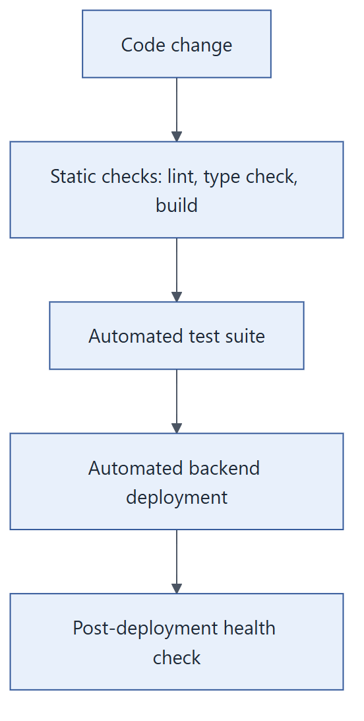
Figure: Quality gates on the way to production.

22.2 Automated tests
Layer | What it verifies
Access rules | Every ownership, delegation and reception rule, line by line
API boundary | All 100 endpoints: sign-in is required where it should be, and each permission-protected endpoint refuses users without the permission
Sign-in | Microsoft and gateway sign-in paths, including rejected and tampered sign-in attempts
Booking logic | Booking, changing and cancelling, conflicts, blocked desks, delegation, history
Visitors | Visitor profiles, visits, reception check-in and check-out
Floor plans and seats | Upload validation, layout lifecycle, desk configuration
Blocked seats | Blocking rules and list performance
Configuration | Validation of every business-rule setting
Notifications | E-mail delivery and retry behaviour when the e-mail service is slow or unavailable
Concurrency | Booking locks are taken before any availability check; a database-level suite for simultaneous bookings of the same desk is included

22.3 Results
Measure | Result
Automated backend tests passing | 438
Endpoints covered by access tests | 100 of 100
Access-rule module line coverage | 100%
Fault-injection check of access rules | 5 of 5 injected faults detected by the tests
Python static analysis (ruff) | No findings
Frontend type check | No errors
Database queries | All parameterised; dynamic parts drawn from fixed lists

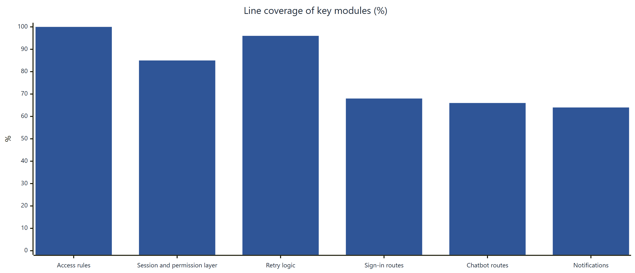
Figure: Coverage of the most security-relevant modules.

Chapter 23. Deployment and Operations

23.1 Environments
Environment | Purpose | Delivery
dev | Development and integration | Automatic on merge to the dev branch
uat | User acceptance testing | Automatic on merge to the uat branch
qa, prod | Quality assurance and production | Supported by the same infrastructure template

Each environment is a separate, identically defined cloud stack.

23.2 Delivery pipeline
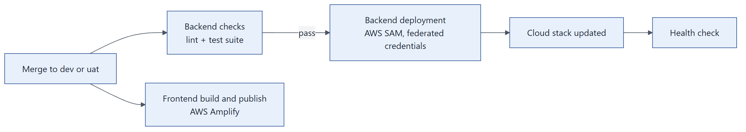
Figure: Automated delivery.
Step | Detail
Infrastructure as code | The API, function, permissions and logs are defined in one AWS SAM template
Backend checks | Linting and the automated test suite run on every backend change
Backend deployment | Builds in a clean container and deploys with short-lived federated credentials
Health check | The pipeline calls the health endpoint after each deployment
Frontend | AWS Amplify builds and publishes the Next.js application per branch

23.3 Runtime profile
Setting | Value
Compute | AWS Lambda, Python 3.14, 1,024 MB memory
Request limit | 30 seconds per request
Concurrency | Capped (default 10) to keep database load predictable
API throttling | 50 requests per second sustained, bursts of 100
Network | Private subnets for the API and database
Logs | Kept for a configurable period (default 30 days)

23.4 Configuration
All environment-specific values (database name, Microsoft application, frontend address, storage bucket, e-mail sender, token lifetimes) are deployment parameters. Secrets are held in AWS Secrets Manager and read at start-up. Nothing environment-specific is built into the code.

23.5 Monitoring
Source | What it shows
Application logs (CloudWatch) | One structured entry per request with request ID, status, duration, organisation and user
API gateway access logs | Every request reaching the API, with route and status
Health endpoint | Service availability
Audit log | Business activity, visible to administrators in the application

23.6 Support quick reference
Question | Where to look
Was a request received and how long did it take? | Application log, by request ID or user
Who changed a booking or setting? | Audit log in the administrator screens
Is the service up? | Health endpoint
Why can a user not see an admin screen? | Their role on the Users screen

Appendix
Terms used in this document.
Chapter 24 Glossary

Chapter 24. Glossary
Term | Meaning
Amenity | A feature of a desk, such as a docking station or standing desk
Audit log | The record of who did what, when, and with what outcome
Blocked seat | A desk taken out of use for a period
Booking | One desk reserved for one person or visitor on one day
Booking window | How many days ahead bookings may be made; set per organisation
Business rule | An organisation-level setting that shapes how SeatBook behaves
Delegated booking | A booking made by a facilitator or administrator for someone else
Desk / seat | A bookable place on a floor plan
Facilitator | A coordinator who books for colleagues and visitors
Floor layout / floor plan | A version of a floor's drawing, with its desks
Front office | Reception staff who record visitor arrivals and departures
Host | The employee a visitor comes to see
Organisation / tenant | A customer organisation using SeatBook, fully separated from others
Site / office | The top level of the location hierarchy
Single sign-on (SSO) | Signing in with the corporate Microsoft account
Tenant admin | An organisation's SeatBook administrator
Visit | A visitor's planned presence on a given day, with host and optional desk
Visitor / guest | A person without a SeatBook account who is registered for a visit

